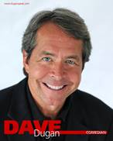
Seen on HBO, COMEDY CENTRAL, FOX and a Regular on the nationally syndicated BOB AND TOM SHOW (with over 250 appearances). Dave's latest comedy special " HUMAN CANNONBALL " is featured on Dry Bar Comedy---and he is fresh off an appearance on “Huckabee”.
" Clean humor with imaginative angles. A very engaging comedian who is also extremely quick on his feet!" The Los Angeles Times
Jim and Martha Dugan’s boy- Dave- was born to be a comedian. A one-of-a-kind delivery accompanied by impeccable timing and imaginative comedy angles has led DAVE DUGAN down the path to NATIONAL TV APPEARANCES and to RAVE REVIEWS.
And TV appearances that go beyond multiple appearances on Comedy Central and HBO? Back when he shaved every two weeks whether he needed it or not, a young Dave headed to Los Angeles from Indiana and within a few months got his first break from the legendary DICK CLARK. Clark included the new Californian on one of his many nighttime music-driven shows on ABC. That led to multiple appearances on the then ratings-leading ARSENIO HALL SHOW and Dave instantly became a favorite at the World-Famous COMEDY STORE IN HOLLYWOOD, a regular writer and contributor on the most popular morning radio show in the country (BOB AND TOM) and can be heard regularly on SIRIUS RADIO. Headlining at theaters and clubs all over the country, Dugan has made a lasting impression with his one-of-a-kind dry, everyman style.
It’s the same natural style that led him to comedy in the first place. Although to hear Dave tell it, he had nowhere else to turn. “Born into a family of home builders, I quickly found that being handy is not necessarily hereditary.” One summer he worked on construction jobs for his dad and quickly found he was allergic to ….hard labor. “In some ways, I think I entered the world of comedy by default.”

One more fun fact, In May, Dave set a WORLD RECORD for number of laps driven around a roundabout (1001 laps and 4 hours and 28 minutes beating the record formerly held by an Aussie )...the quest helped raise thousands for cancer programs and services. At their annual fundraiser, the charitable organization presented Dave with an award to acknowledge his world record for charity. Dugan claims, ‘‘it is the only award I have ever won, unless you count Honorable Mention for my 5th Grade science fair project----The Digestive System.”

CORPORATE COMEDIAN, KEYNOTE, EMCEE, IMPOSTOR
LIKABLE, EVERYMAN - "SMART, CLEAN AND QUICK"
AUTHOR OF “LAUGHING YOUR WAY THROUGH LIFE”

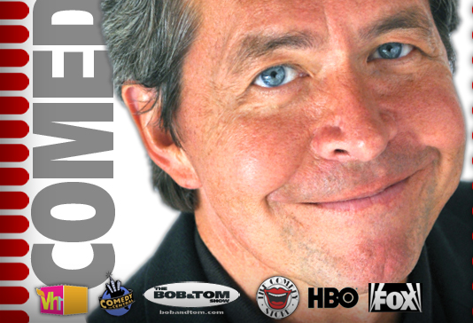

Brace yourself for positive feedback!
"Just a quick note to tell you how much we enjoyed Dave Dugan’s performance! He is smart, wickedly funny, and quick – with impeccable timing. We loved him.”
Rene S. Wyandot Memorial Hospital
----------------------------------------------------------------------------------
“Dave was very, very entertaining as our keynote speaker. But first, we had him improvise as an imposter. Using our industry language - he made it genuine and over the top hilarious! I received accolades that it was the best sales conference that we’ve ever had and I believe Dave was a big part of that. We look forward to having Dave return to a future event!”
John B. Anthem Blue Cross & Blue Shield
------------------------------------------------------------------------------------
“Dave Dugan’s “Laughing Your Way Through Life” presentation was beyond expectation and just hilarious! He is highly recommended!! “
Karen T. Saginaw Town Hall
-------------------------------------------------------------------------------------------------------
“Dave had us in stitches from start to finish. The evening of comedy and caring went by so fast! Dave is a class act!”
Mike H American Red Cross
---------------------------------------------------------------------------------------------------------
“ Dave’s performance was Spectacular! He was so funny and engaging. We would highly recommend him.”
Sasha V. American Bar Association
--------------------------------------------------------------------------------------------------------
“On behalf of McDonald’s, thank you for a show that delivered exactly what we were looking for----a funny and relevant performance. You did a wonderful job of tying together comedy that was linked to the industry. You’ll be hearing from us again!”
Jon R. -- McDonald’s
---------------------------------------------------------------------------------------------------------
“A stellar performance! We had nothing but great feedback! Dave’s ability to bring our company’s quirks into his presentation and make finance funny isn’t easy but he made it look easy. Dave is extremely funny and we booked him again for this year and we will again next year. He’s become a given for our annual conference! And lastly his voice is phenomenal!”
Susan F. PNC Investments

“Your integration of our business into your monologue was a stroke of sheer genius. I knew you had the group hooked when I saw both our vice president and our director of worldwide manufacturing leaning back in their seats with their knees drawn to their chest because they were laughing so hard!”
Carolyn L. - Meritor
------------------------------------------------------------------------------------------------------------
“Exceptional humor! Dave delivered a very funny routine customized to resonate with our employees. “
Selita R. Red Gold
------------------------------------------------------------------------------------
“We received tons of compliments about Dave Dugan’s very funny, very relatable presentation. He even got a round of applause the following morning when the CEO asked if the employees enjoyed it.”
Eric B. Indiana Municipal Power Agency.
-----------------------------------------------------------------------------------------------------
“Dave Dugan had us thoroughly entertained. We laughed from the minute he took the microphone until the cheers at the end of his performance. Don’t think I have ever witnessed anyone with that quick of a wit!”
Nan E. - Consumer Electronics
------------------------------------------------------------------------------------
“Your performance was the highlight of the event and got rave reviews from everyone! Should the opportunity arise for me to be in charge of entertainment -you will be my first and only call!”
Tadd F. Farm Bureau Insurance

“Dave Dugan’s performance AND great wit really helped make our event a smashing success. And he even created an audio tribute for the founder of our company which was the perfect blend of humor and sentimentality.”
Janet C. Towne Properties
----------------------------------------------------------------------------------------------------
" Dave Dugan’s clean humor and uncanny ability to take our human nature and put it in such a way that each of us was able to laugh at ourselves led to nothing but positive responses! ‘Laughing Your Way Through Life’ was a perfect choice for our group!"
Becky H. Oakland Town Hall
----------------------------------------------------------------------------------------------------
"Dave Dugan kept our audience entertained by combining our government jargon with localized humor during our wellness initiative-- "Laugh off the Stress and Wellness Fair" day. The perfect start for our event---I would highly recommend Dave

